- Create TT Class Virtual “CD” Folder Shortcut—locate the TT main folder desktop shortcut—path C:\Users\Public\Documents\TT—and create a desktop shortcut for the teaching textbook (TT) class for your student (Figures 1-3).
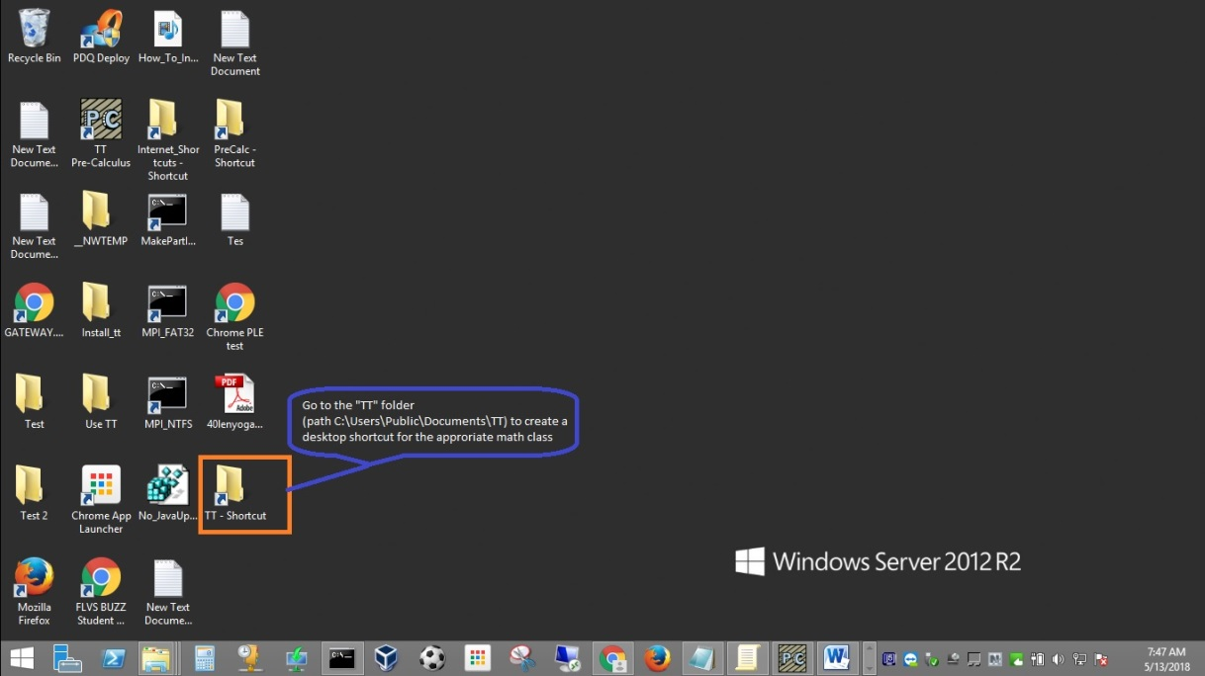
Figure 1
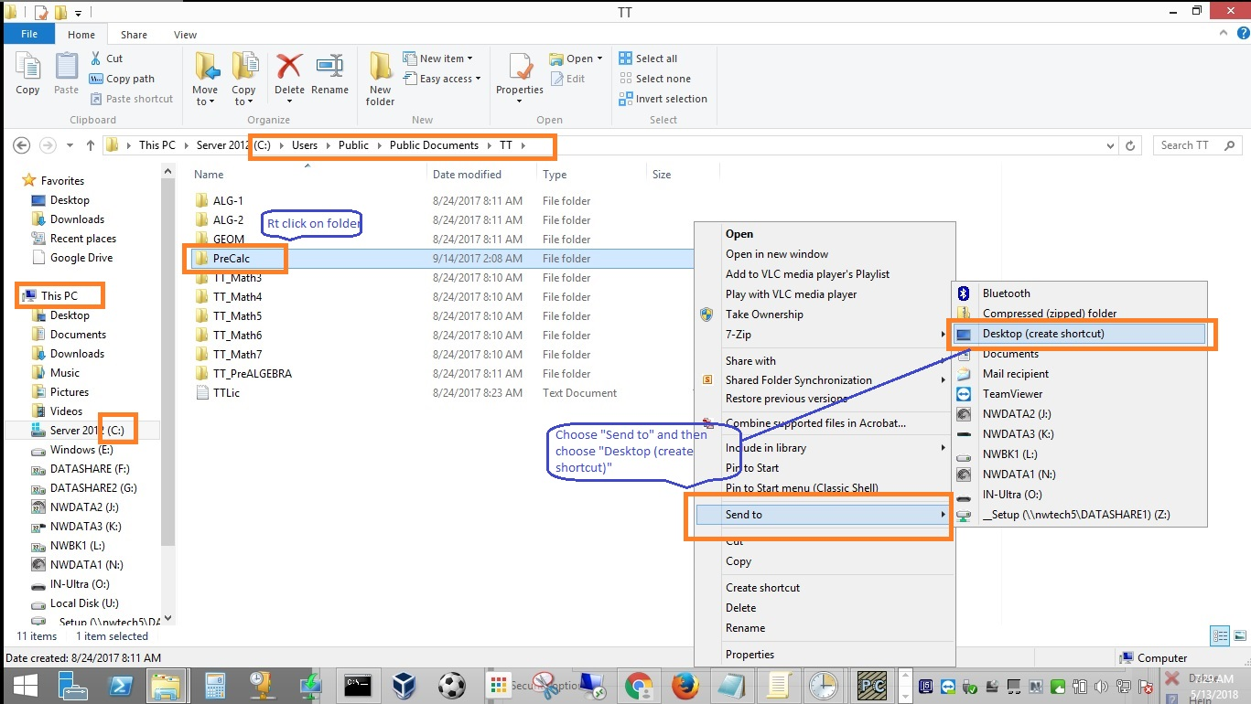
Figure 2
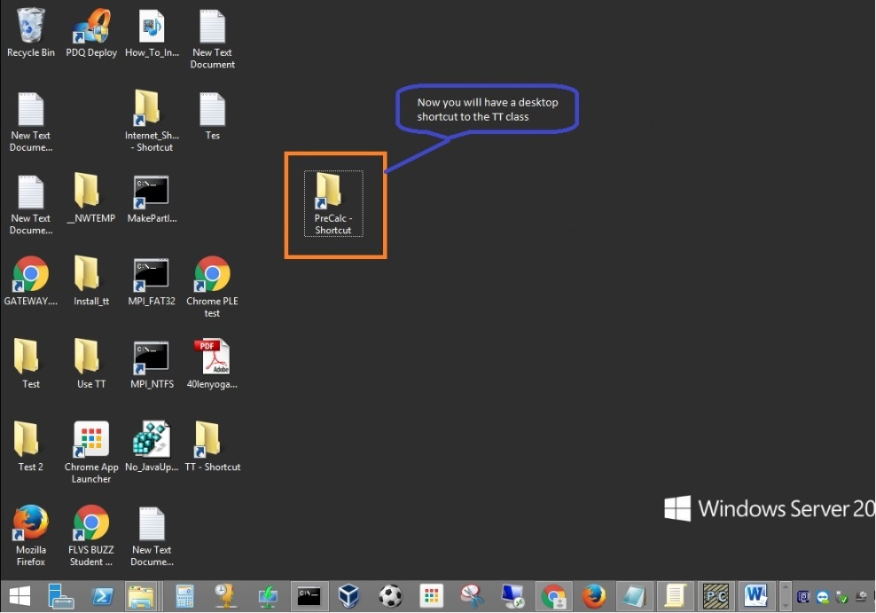
Figure 3
- Install—Double click to open the class folder where the virtual “CDs” are located (path C:\Users\Public\Documents\TT\) and double click on class name-1 virtual “CD”. Choose “Run Autorun.exe” and follow “next>next>finish” steps to install the teaching textbook (TT) class for your student. (figures 4-6).
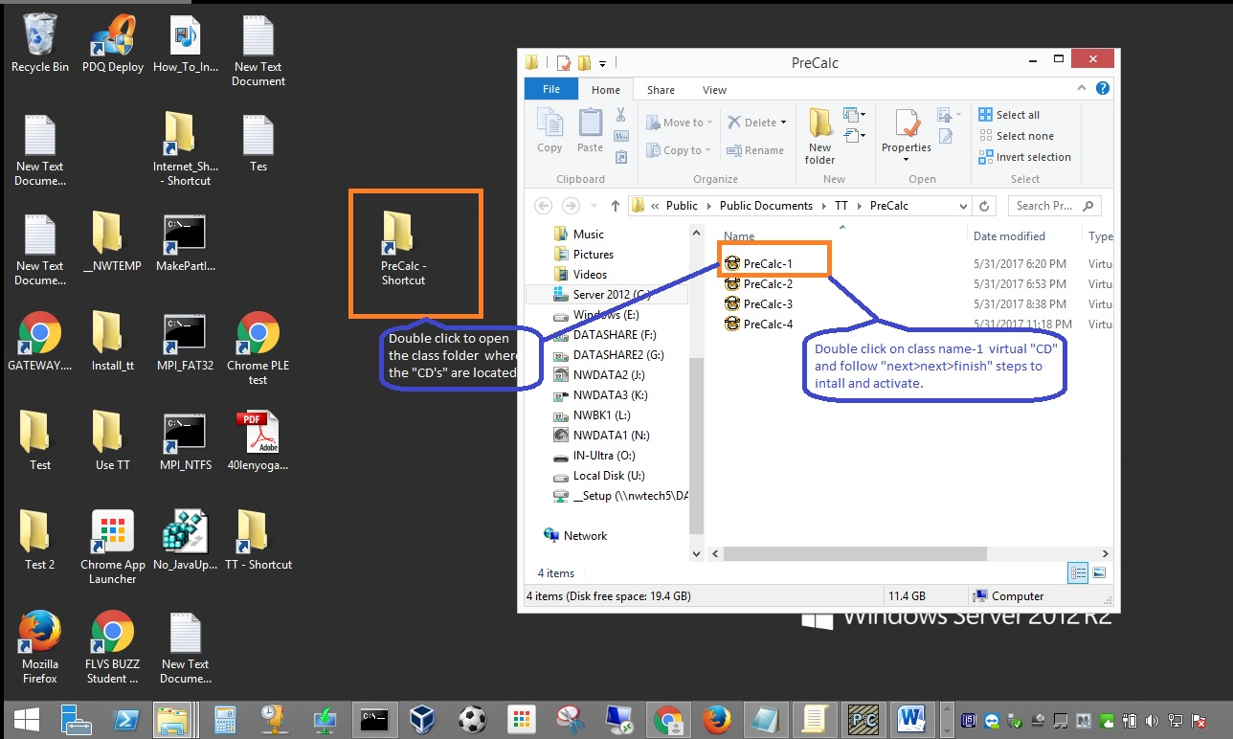
Figure 4
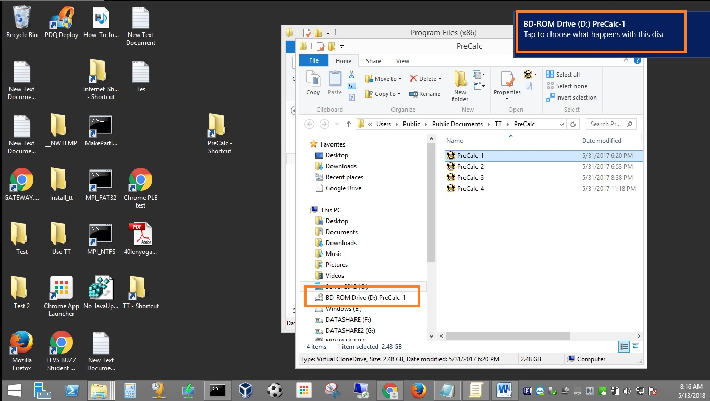
Figure 5
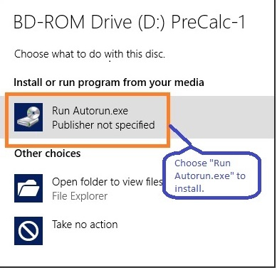

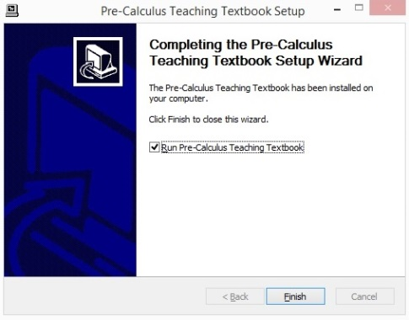
Figure 6
- Activate and set up TT class—Open the TT license notepad document located at "C:\Users\Public\Documents\TT\TTLic.txt" to find the correct license to be activated for your student. Note: SRCS staff will identify, determine and provide you the correct activation code because each TT license can be used for 5 SRCS students. Please activate by entering the information as pictured to help us keep track of each shared license (figures 7-9).
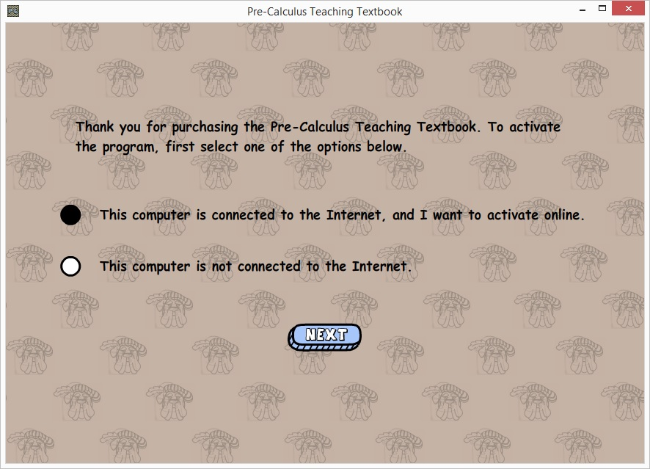
Figure 7
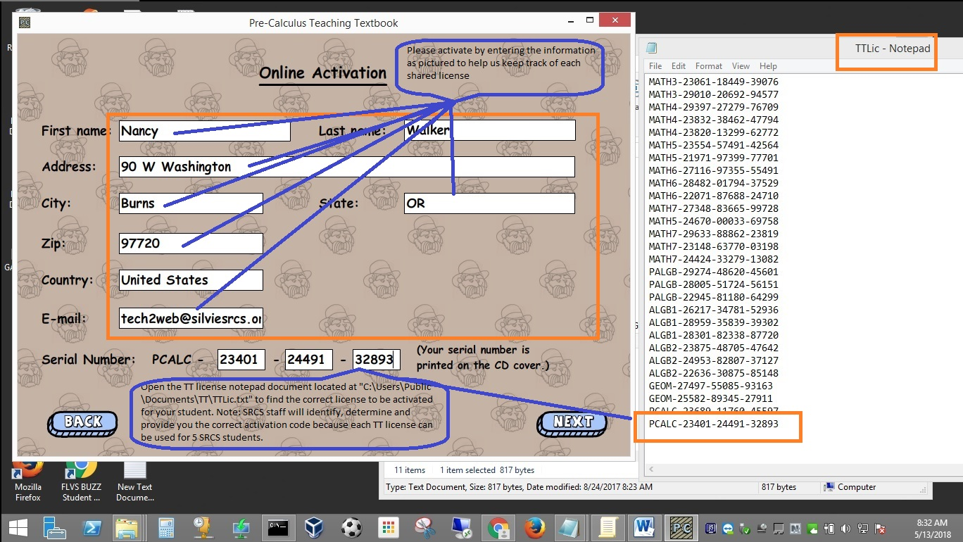
Figure 8
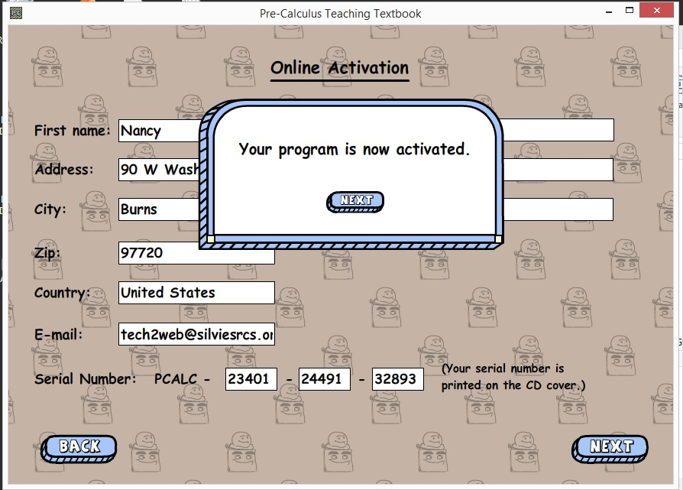
Figure 9
- Set up and use virtual “CDs” for your student’s activated TT class—set up parent and student TT accounts and start with lessons on class name-1 virtual “CD”. If you get the “oops” message, please go to the TT class folder where the CDs are located (see Figures 4, 10-12).
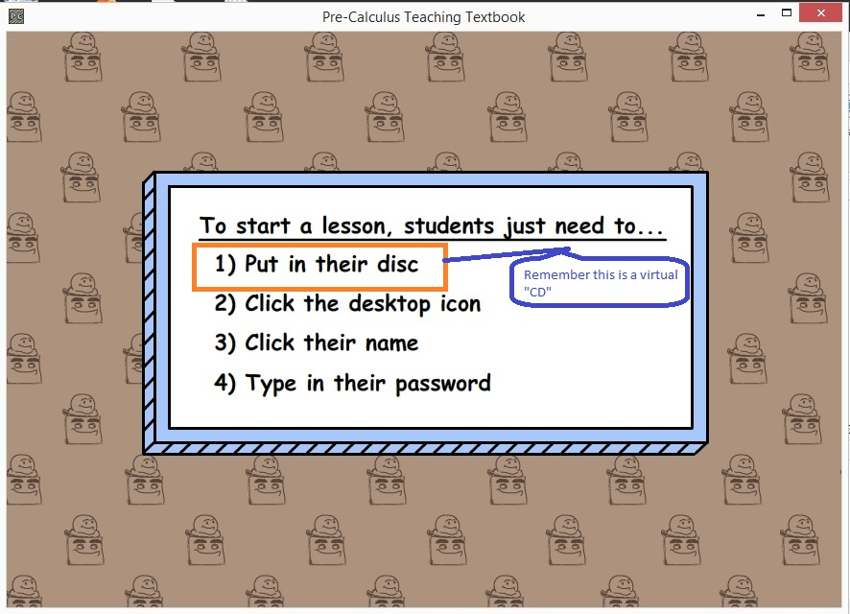
Figure 10
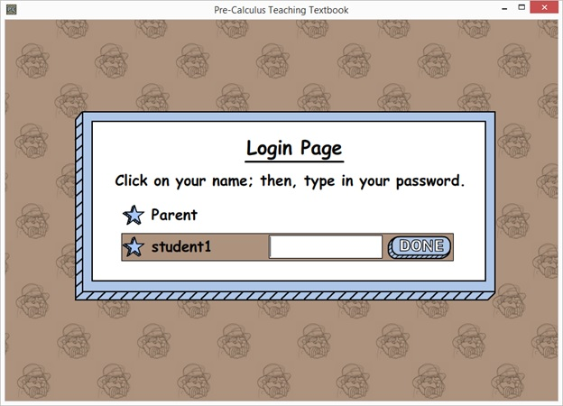
Figure 11
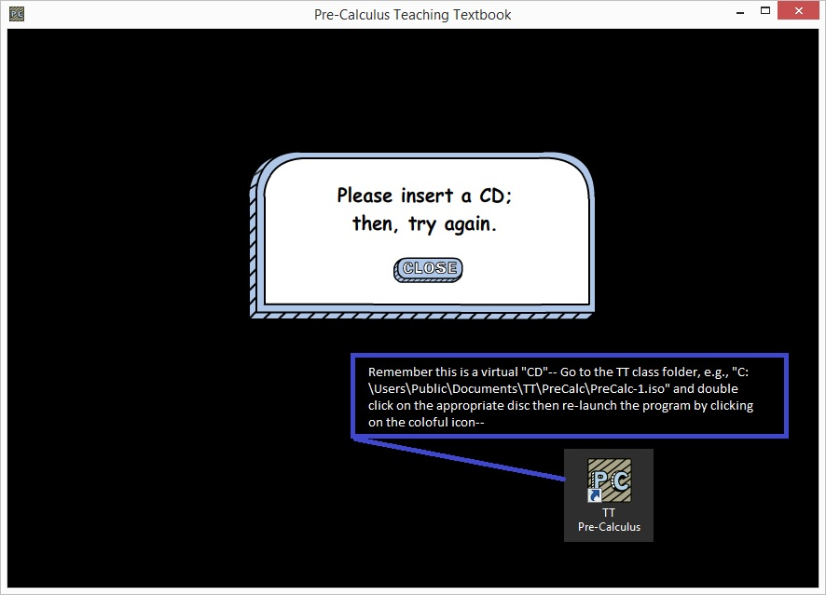
Figure 12

